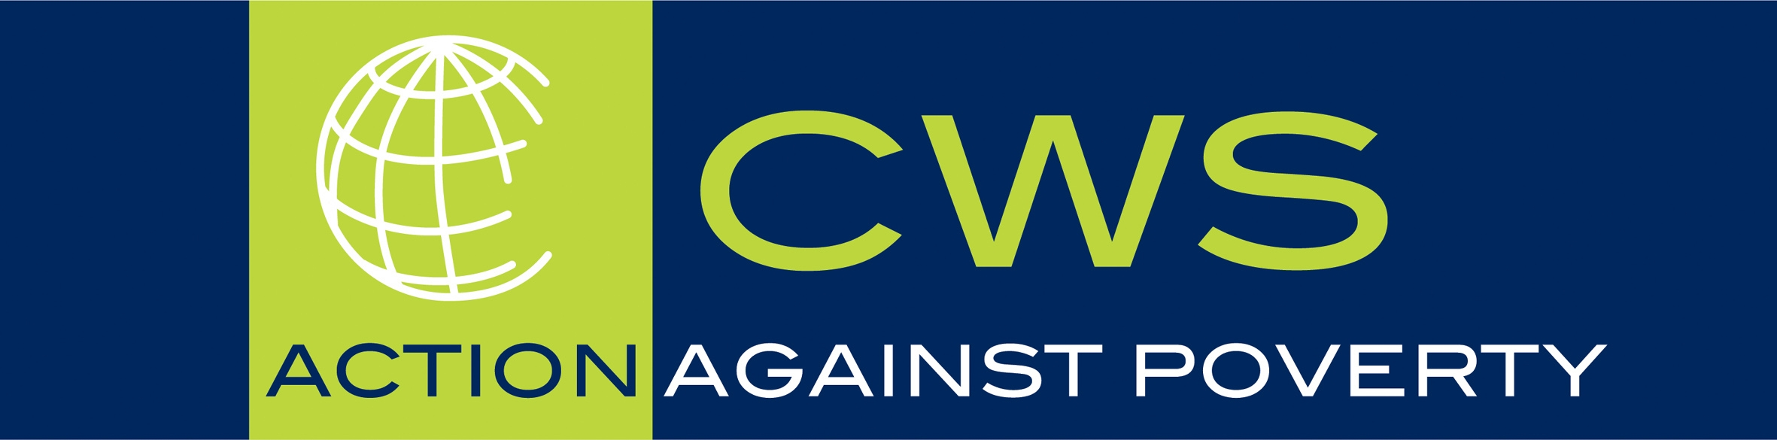
Christian World Service
PO Box 22652 Christchurch
Ph: 03 366 9274 Fax: 03 365 2919
cws@cws.org.nz www.cws.org.nz

Media Release
7 May 2004

Christian World Service says listen to Maori on the Foreshore and Seabed

New Zealand aid and development agency, Christian World Service, supports Maori in their bid for a just resolution on the foreshore and seabed issue.

“The hikoi was a clear and uncompromising message to all New Zealanders from Maori,” said Jonathan Fletcher. “The dispersal of the hikoi cannot be the end of debate on the Foreshore and Seabed. Maori have expressed their opposition to the Bill and it is up to all of us to ensure that a just solution is found.”

The hikoi demonstrated the widespread opposition amongst Maori to the Foreshore and Seabed legislation and Maori anger at the way the Government is once again using parliamentary process to strip iwi and hapu of their rights and resources.

“As an organisation that takes seriously its obligation to honour Te Tiriti O Waitangi and its commitment to work alongside Maori for a just and equitable society, we have been deeply saddened by the Government’s hasty efforts to bring legislation to Parliament,” said National Director, Jonathan Fletcher.

“This legislation is a litmus test of the Government’s commitment to its relationship with Maori and I am sorry to say it falls short,” he added. “The Select Committee process is the last chance the Government has to fulfil its obligations under Te Tiriti O Waitangi. It is important that those who recognise the Government’s obligations under the Treaty make sure that the rights of Maori are protected.”

The legislation appears to confiscate both access and the right of iwi and hapu to exercise their traditional responsibilities over these resources. It will require them to prove that they have exercised this practice “substantially uninterrupted since 1840”.

“It is not a fair expectation when so much of the land adjacent to the foreshore and seabed has been taken from iwi and hapu, and when they have been denied their sovereignty,” he added. “Neither is it right that the government provide open access to the foreshore and seabed by committing a new injustice to Maori.”

- For further information contact Jonathan Fletcher 021 267 2278 or
Gillian Southey 389 7843
- Notes follow

Christian World Service is the Development, Justice and Aid Agency
of the Conference of Churches in Aotearoa New Zealand

Christian World Service says listen to Maori on the Foreshore and Seabed

Notes to media release 7/05/04
Christian World Service has a long history of supporting groups struggling to ensure that their communities have a decent livelihood and access to their traditional resources throughout the world.

Christian World Service wrote to the government in August 2003 urging the government to carefully consider the issue, to listen carefully to Maori and not extinguish their customary rights. It made a grant to the Ecumenical Coalition for Justice based in Auckland to prepare study resources for churches on the Foreshore and Seabed issue. (www.socialjustice.org.nz)

In October CWS made a submission on the Foreshore and Seabed policy asking for a fairer process that respected Maori rights. In April 2004 Christian World Service wrote to the government expressing sadness over the nature of the current Bill and the way that it had not fulfilled obligations under Te Tiriti O Waitangi. Staff and supporters have participated and supported the hikoi and the organisation has also made a small solidarity grant to the hikoi organisers.

Foreshore and seabed information page http://www.converge.org.nz/pma/fsinfo.htm

