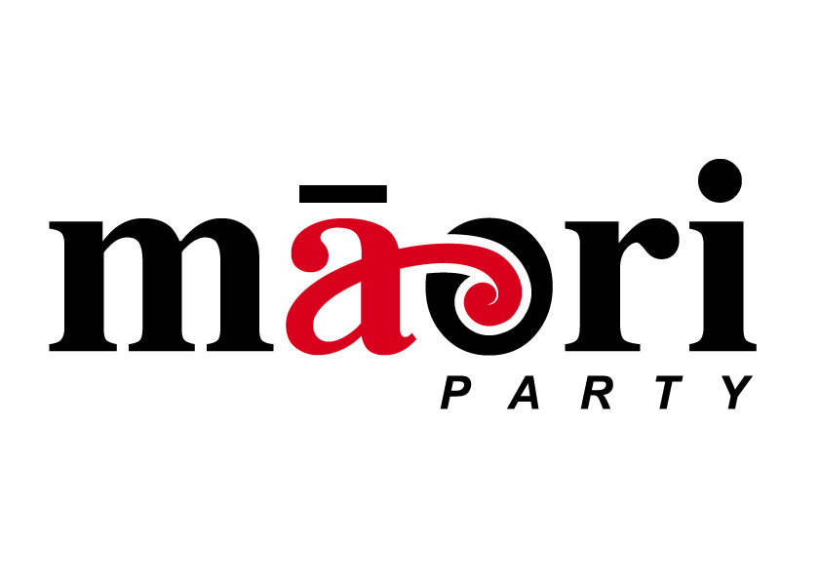

MAORI PARTY APPALLED AT FORESHORE AND SEABED FIASCO

16 November 2004

‘Dr Cullen’s belief that the Foreshore and Seabed Bill will result in a ‘swing of Maori support back to Labour’ is nothing more than a delusion’ said Mrs Turia today after the second reading of the Foreshore and Seabed Bill.

‘Our people will never forget that this Government was prepared to extinguish another Maori inheritance, this time to the foreshore and seabed, an inheritance that is recognised in tikanga’ stated Mrs Turia.

“Tangata whenua, and many other New Zealanders, have been treated with contempt’ stated Mrs Turia. ‘The significant investment that thousands of New Zealanders have made in putting their views forward, will now be seen to have counted for nought’.

‘After 18 months of feedback, 4000 submissions, 300 appearances at select committee, demonstrations in their thousands, and endless commitment to stating their opposition to the Bill, the extent of their influence on the final product is neglible’ said Mrs Turia.

‘I was appalled to not receive the final version of the Bill until earlier this evening’ commented Mrs Turia.

‘It beggars belief that a document that has such lasting significance for our nation is represented to the Parliament with no time for reflection or considered thought’.

‘Here we have a Bill which is one of the most defining pieces of legislation in our recent history, being treated so lightly by this Government’.

Media inquiries

Helen Leahy, 021-881-031

