Fasting for the Foreshore

Betsan Martin PhD
Wellington and Turangi

June 20, 2004

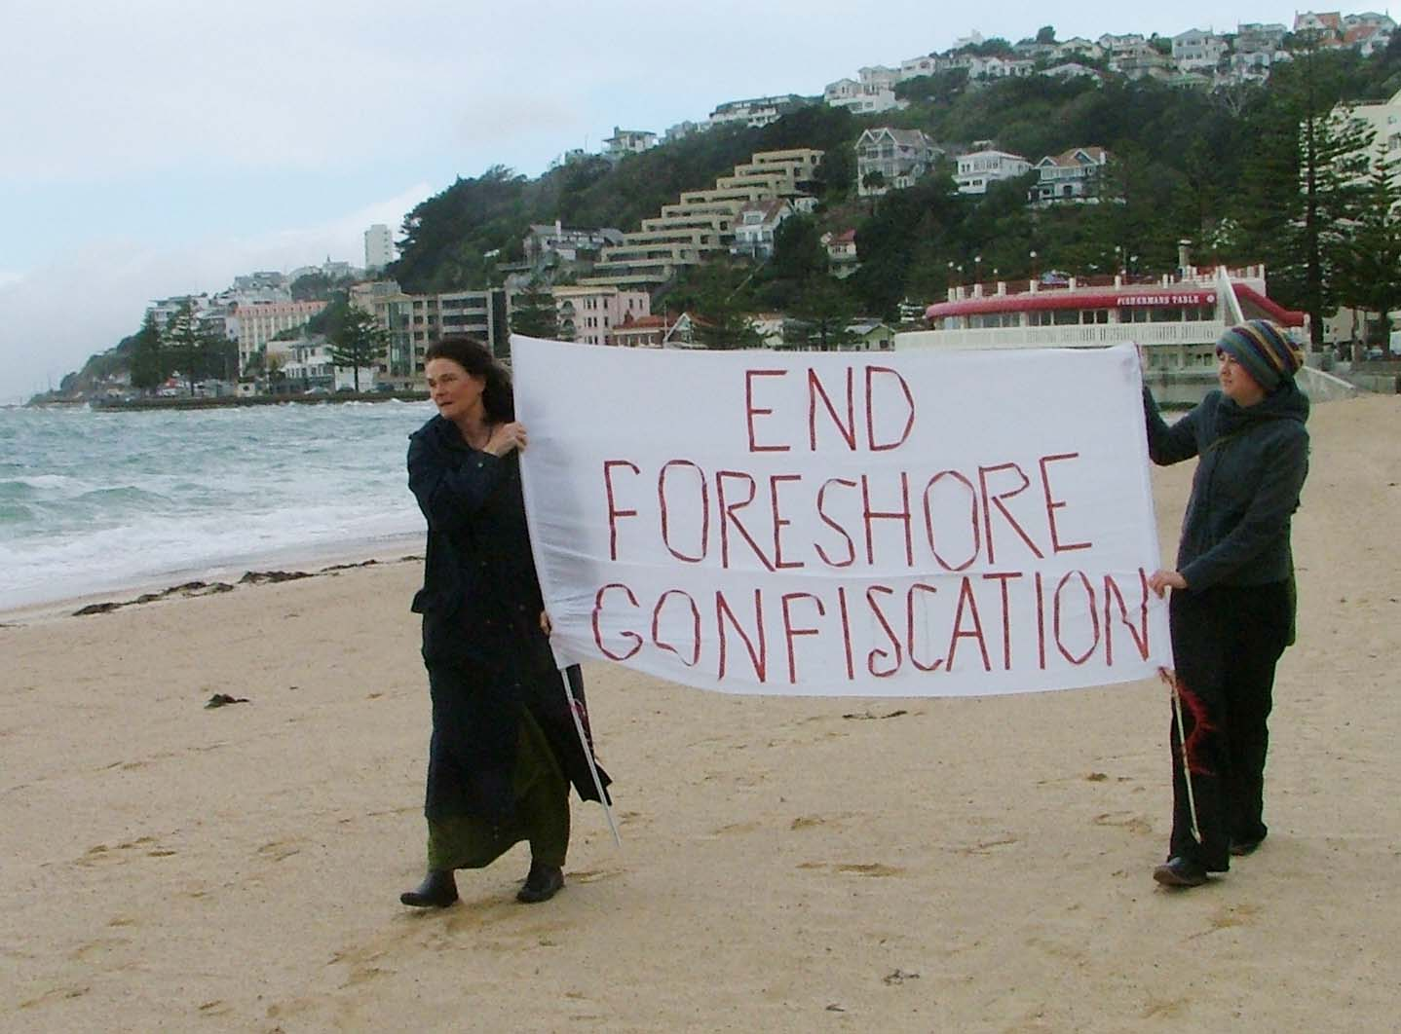
Photo by Derek Chen

Introduction. Governance of the Foreshore sweeps onto our horizon
Fasting for the Foreshore comes from shock at the impending confiscation of the Foreshore and Seabed. The extinguishment of customary titles will be judged by our children and their grandchildren with the same horror as the legal processes of confiscation of the 19th century. This Pakeha fast is to alert New Zealanders generally, recognizing that Government will go no further than the general opinion of voters. Fasting is a lament for the foreshore confiscation.

New Zealand has the opportunity to bear the fruit of Te Tiriti o Waitangi and create relationships with tangata whenua that ensure continued customary governance. This includes supporting kaitiakitanga as a culturally-integrated method of responsibility for people and the environment. It is possible to envisage indigenous governance, tino rangatiratanga, being implemented alongside governance from the western liberal tradition. These provisions come from Te Tiriti o Waitangi which provided for peoples of 2 world views to share Aotearoa respectfully by instituting systems that gave effect to these agreements.

The liberal system has the capacity for adaptation. Indivisible sovereignty was an adaptation. Nowadays the crisis of the degenerated natural world is making space for environmental science and ecological knowledge, with the beginnings of remedial policy provisions. Sustainable governance and resource use have always been intrinsic to indigenous societies.

Co-governance. An interplay of two systems
A version of sovereignty as indivisible has been constantly invoked to quell legal and political space for tino rangatiratanga, and for a Tiriti based constitution. Sovereignty can be divided, as shown in Canada and the United States, and as legally argued by Justices Sian Elias and E. W. Thomas.

Co-governance may sound straightforward philosophically; in practice it will need further careful, even laborious legal argument. The concept implies parity, but is not to be reduced to ‘equality’. Tino Rangatiratanga and kawanantanga are different, and distinct. Each expresses integrity with their traditions for governing responsibilities. Tino Rangatiratanga emanates from locally based indigenous societies to regulate and uphold law, and sovereign governance is a centralized order derived from the liberal tradition and evolved absolute sovereign authority, established in New Zealand as indivisible. Upholding the two is not a contradictory proposal, rather it brings the requirement to find systems that span the two.

The challenge of co-governance would be to institute structures which express the governing responsibilities of each party. A Treaty based upper house is one such proposal; A Treaty constituted supreme court is another. Policy would flow from institutional innovation and need to be sustained with a flood of public education, and inspired methods of mediation for inter-course. The structures, like those of a two-hulled waka, requiring strength and flexibility to endure and to adjust to changing seas. New proposals would surely emerge in such an environment.

Reference to our current realities tells us that there are overlaps between the ‘two worlds’ that make these distinctions too simplistic. Maori participation in all levels of kawanantanga institutions is more the order of the day, with notions of rangatiratanga less in public view, and being sustained in te ao Maori, Maori world views.

The tidal rhythms will ensure an ever evolving discourse on governance, as experienced with the huge hikoi wave crashed onto the shore of parliament. Governance of sea and land are the order of the day, and cannot be isolated from control of resources and international positioning and trade, as consistently made clear by Jane Kelsey, Annette Sykes and others. As we know from the prosperity of nga iwi Maori pre 1860’s, economic enterprise is set to be enhanced by prizing open sovereignty and reconceptualizing governance.

Te Tiriti, assimilation, diversity
Growing roots and allowing the sap to rise to attain our full height keeps being prevented by ring-barking. The imagination of Pakeha and New Zealanders who have come as later settlers has been hamstrung by policies of assimilation and the constrictions of a mono-cultural world-view. Now, there is popular evasion of Te Tiriti or ‘two peoples’ principle as a basis for nationhood with the increasingly diverse population and our willingness to find ways to be hospitable to people who are coming here from different places. Diversity is about enabling diverse peoples to fit in to the prevailing ways of life. If you dig deeper, it positions ‘Maori’ with immigrant communities, flying in the face of the now internationally recognized status of indigenous people. Te Tiriti-based diversity, with immigration policies flowing from co-governance arrangements would correspond to the hospitality in indigenous and liberal traditions.

Legislation has been a means of confiscation since 1863. Pakeha Treaty educators refer to this history to bring an historical appreciation of Maori advocacy for Te Tiriti and a sense that the present has evolved from the foundations laid last century – a Foucauldian ‘history of the present’. In our wildest dreams, it has never been considered that this history could be repeated. The Waitangi Tribunal seemed a symbol of a turn towards respect for Te Tiriti agreements. The tribunal has reported that the government Foreshore and Seabed proposals are in breach of the Treaty, yet the bill has proceeded into Parliament

Foreshores and Seabed
From the beginning of the Foreshore and Seabed proposals I have been arrested by themes that are being replayed to appease the ‘later settler’ majority – themes that are recognizable since the inception of the 1835 Declaration of Independence. Majoritarian ideology of government became more insistent since 1858, when the settler population outnumbered that of the tangata whenua, and was asserted through ideas such as policy in ‘the interests of all New Zealanders’, one law for all, representative and then democratic rule.

Underlying these themes the assumption of Sovereignty being ceded to the Crown has been a central interpretation of the Treaty of Waitangi. A theme that resurfaced recently was the difficulty of negotiating with ‘Maori’ because there is no central ‘body’ that represents them – an echo of the ideology of ‘one’ sovereign as the legitimate representative of a group of people. And so we saw consultation hui prescribed by government agenda and time frames to conform to the requirement to ‘consult’ with tangata whenua. It was a farce, in that no notice has been taken of the overwhelming collective voice of those who were consulted.

The need to clarify territorial, or radical title could be put up for resolution between the crown and hapu, the customary title holders. Even joint ownership may be regarded as compromising tino rangatiratanga (as well as compromising indivisible sovereignty). Provision for an ethical solution will take longer than one political year. We have seen generosity prevail where the mana of rangatiratanga is upheld, such as at Lake Taupo and Orakei.

Public access to the foreshore and any other recreational environment is the issue that rallies an outcry from all New Zealanders who feel as risk of being shut out. But this is not a recent concern brought about for the Foreshore.

Public access was used to assert the ‘interests of all New Zealanders’ in Lake Taupo – a strategy through which the Taupo lake bed was transferred to the Crown against the wishes of Tuwharetoa in 1926. After 56 years of appeal, titles to the lakebed and river-beds were restored to Tuwharetoa. When you read the historical material, Crown ownership is really about control of resources – in this case the recreational resources attached to trout fishing. Public access has been beneficial to all NZers under the joint management arrangement. The challenge now is for a re-alignment to be found from the council side, to move from commercial interests to environmental responsibility, to catch up with the kaitiaki model of management.

Foreshore and Seabed bill
This week of fasting brings the opportunity to re-examine articles on the Foreshore and Seabed, and the bill before parliament. To comment on a few:

The vesting of the Foreshore and Seabed in the crown violates customary entitlements safeguarded under the doctrine of aboriginal title in common law. In legal discourse, even Crown sovereignty is ‘burdened’ by obligations to uphold customary titles. These can only be extinguished by an Act of parliament with the agreement of the customary owners.

It is abhorrent that customary orders and ancestral connection are o be nominated by the Maori Land Court. Here customary practice is being over-ridden and replaced by court defined entitlements, fracturing the integrated, wholistic economic, social and spiritual basis of hapu societies. If any court process is required in respect of customary orders it should be as an onus on the Crown to prove its acquisition of titles with documentary evidence.

The provision of the high court to recognize customary or aboriginal rights/titles that are now extinguished, is the most unethical treatment of customary entitlements that signal disdain for indigenous law and disregard for the cultural integrity of hapu.

It is implied that the replacement of iwi authorities by ‘holders of ancestral connection orders’ in the Resource Manangement Act introduces a diminished status that was accorded to Iwi Management Plans in the RMA.

Over all the Foreshore and Seabed bill heralds a litigious, adversarial future for tangata whenua and government, adding to the already entrenched burden of litigation upon tribes for settlement of grievances. These violations suppress the openings to evolving a vibrant Aotearoa-NZ possible from an interplay between our different traditions, and premised on en ethics of manawhenuatanga.

All these terms, such as ownership, exclusive titles, customary orders, ancestral connection are terms that are alien to the ancestral law of tangata whenua. They belie the pre-eminent values of property and freedom that derive from the liberal tradition, rendering obsolete the relational values and custodial responsibilities of kaitiakitanga, manaakitanga, whakakpapa, tikanga, rangatiratanga, mana… as elaborated by Eddie Durie and others.

An elucidation on rangatiratanga from E. Durie: ‘ political power was vested in the basic community or hapu level. Power flowed from the people up and not from the top down. Control from a centralized or super-ordinate authority was antithetical to the Maori system. It is probably an understatement to say that Maori did not develop a central political agency, and more correct to assert that Maori ethic was averse to it. Where Europeans saw progress in the aggregation of principalities to form nation states, and the world followed suit, for the indigenous societies of Australasia and the Americas, local autonomy was more prized. …Tribal societies do not see themselves as an undeveloped embryo but as maintaining a way of life independent of the state as a matter of positive policy’.

Conclusion
Some of our eminent writers such as Judge Eddie Durie and Dame Anne Salmond are showing the way to a future where the worlds of Tikanga Maori and of the liberal tradition can meet in a spirit of generosity and eminent respect for the legacies of these traditions, as a basis for accommodating a new world in the Pacific, which traditionally has been hospitable to diverse populations.

Let the Foreshore bill be withdrawn. Let a new future be inaugurated which evolves from an ethic of upholding the wisdom of those who are indigenous to the Pacific, with honour given to the liberal traditions informing later settler institutions, and conditions created for shared responsibility for governance.

