IN THE FORESHORE & SEABED DEBATE, BOTH LABOUR AND NATIONAL HAVE AND
WILL DEFEND THE PROPERTY RIGHTS OF WEALTHY COMMERCIAL INTERESTS…

In the seabed debate, the key issue is property rights and ownership of resources.
Both National and Labour have acted unilaterally on legal advice to block Maori
claimants from gaining a favourable ruling from the Maori Land Court. Under existing law and the Treaty of Waitangi (Article 2) , the Maori Land Court could give no other ruling than that Maori had a ‘property ownership right’ to the foreshore.
19th Century History being Repeated
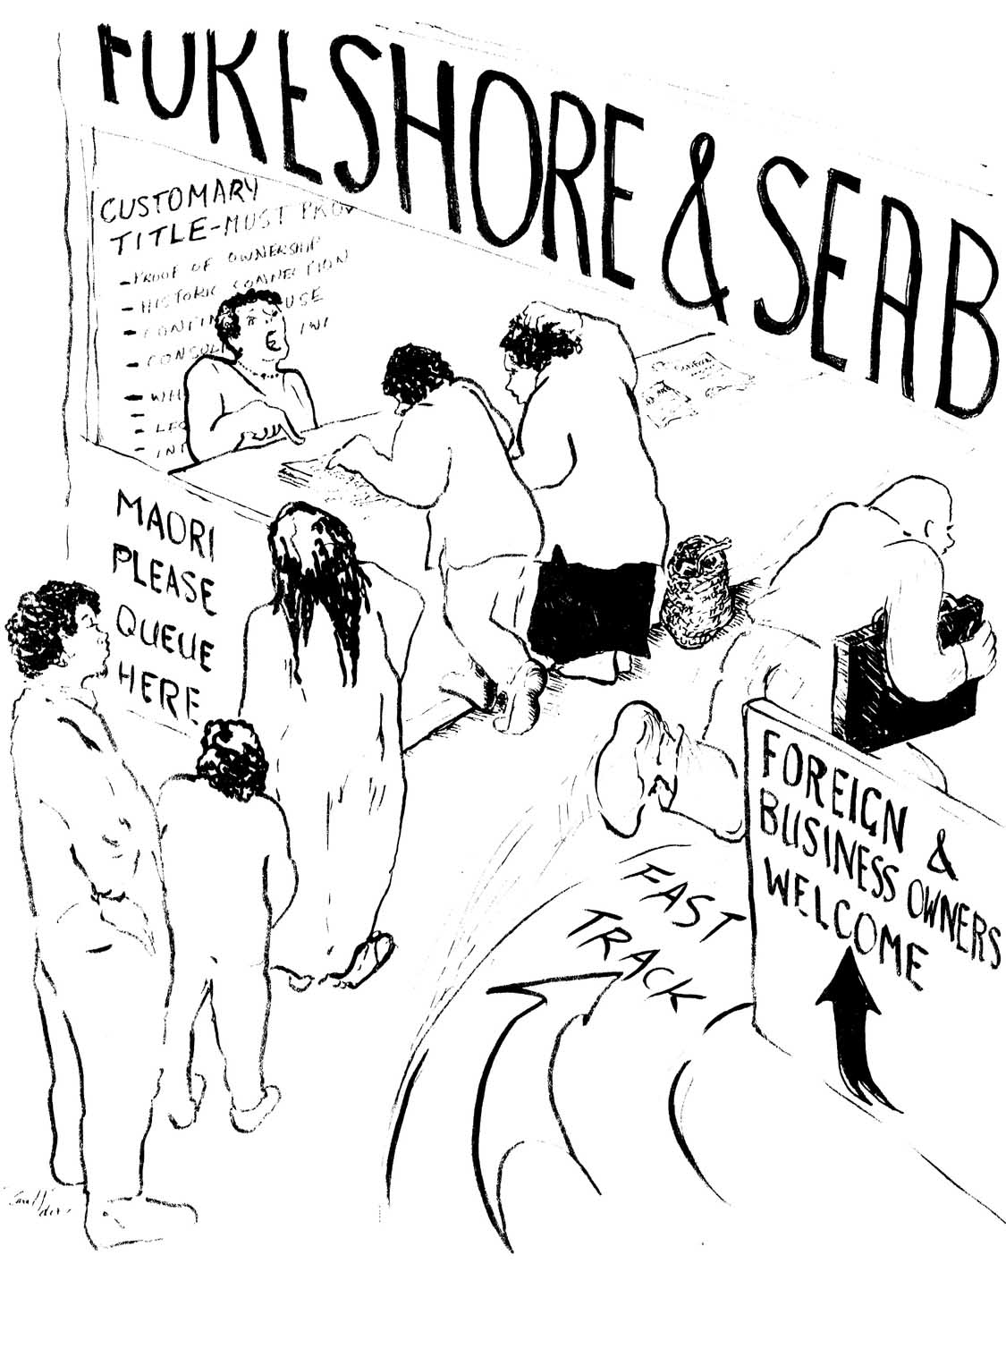
In the 19th Century, Maori land and resources were illegally confiscated. Maori property rights in land were ignored by the governments of the day.
In recent years, these illegal confiscations resulted in some Treaty settlements.
Now, our government has once again denied Maori their property rights over their foreshore land and resources.
The shameful and illegal 19th Century confiscation of Maori land and resources is being repeated - in our names, in our time.
Commercial interests and private owners bar others accessing the beaches and foreshore – NOT Maori who have generously shared the foreshore for 163 years.

There is no record of an agreement, or Treaty between Maori and the Crown that Maori Land ownership ceases at the high water mark and / or that excludes the foreshore land down to the low water mark . Quite clearly, Maori property rights include land down to the low water mark – the foreshore, and beyond, to the seabed itself.
Commercial Interests Get Government Support
In the 19th Century, Maori-owned land was the richest resource – especially as it could be obtained for a pittance. This land attracted determined and unscrupulous land speculators, land grabbers, devious banking services, real estate dealers, merchants and squatters: people with real political influence.
A compliant Government illegally confiscated millions of acres of Maori land. Today, once again, commercial interests have decisive political influence. Like the 19th Century, land grabbers and speculators, their modern day equivalents try to prevent the recognition at law of Maori property rights to the foreshore.
Because :
1. above average profits can be made by developing marinas, coastal subdivisions, marine farming.
2. Those in current illegal possession of foreshore would lose ownership.
3. Private or public owners would be liable for
payment of rent or compensation.
These ‘commercial interests’ illegally using Maori foreshore land include government departments, port companies, ship repairing, boat building, owners of off-shore islands, non-Maori owners of foreshore, coastal property owners with riparian rights. Marine farmers, mining and tourist interests. These commercial interests want free access to Maori property to accumulate extra wealth, just as their counterparts did in the 19th Century
A NEW CONFISCATION: NOT IN OUR NAME
In Aotearoa/ New Zealand, community well being and social justice is based on recognising majority interests, including good relations between Maori and Pakeha. Those commercial interests involved in foreshore activities are a small minority . They seek above average profits at the expense of Maori land and resources. Central Government should cease pandering to their greed.

We invite you, to send a postcard to the Prime Minister, seeking her support for Maori ownership of the foreshore, for principled consultation for an agreed settlement, for the right of Maori to have access to the Maori Land Court and for her Government to refrain from another illegal confiscation.
Published by Network Waitangi Whangarei, February 2004.

