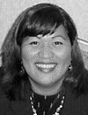
You are invited to a public meeting with

Senator Abacca Anjain-Maddison
Rongelap, Marshall Islands

who will speak about the impact of US nuclear weapons testing on the people of Rongelap, the ongoing struggle to get compensation and medical assistance from the US government, and plans for a Rongelap Peace Museum to educate about the horrors of nuclear warfare.

When the US government signed the UN Trusteeship Agreement for Micronesia, they promised to protect the people, their island homes and surrounding ocean, and to assist them to move towards self-government or independence as determined by the wishes of the people.

Instead they exploded sixty-seven nuclear bombs in the Marshall Islands. Some islands were completely obliterated in the nuclear bomb blasts; and others were so contaminated that people may never live there again, nor safely gather food and other resources from the surrounding ocean.

On 1 March 1954 the US armed forces detonated a nuclear bomb in a test codenamed 'Bravo' - it had an explosive force almost 1,000 times larger than the bomb exploded over Hiroshima. Fallout from 'Bravo' contaminated an area of 7,000 square miles. Rongelap was directly in the path of the deadly radioactive cloud produced by the blast.

The people of the Marshall Islands were used as human 'guinea pigs' in the US government's insane pursuit of nuclear weapons supremacy. Their way of life has been seriously harmed, their environment irreparably poisoned, and they have suffered appalling health problems - including genetic damage which means that future generations will be similarly affected.

7pm, Tuesday 7 December

McKenzie Room, St John's in the City Conference
Centre, corner Willis & Dixon Streets, Wellington

For more information about US nuclear weapons, ballistic missile, and 'Star Wars' weapons tests in the Marshall Islands see www.converge.org.nz/pma/rmi.htm

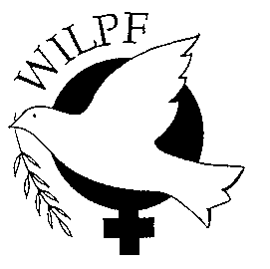

Women's International League for Peace and Freedom (Wellington Branch), contact tel (04) 382 8129 or email pma@xtra.co.nz

