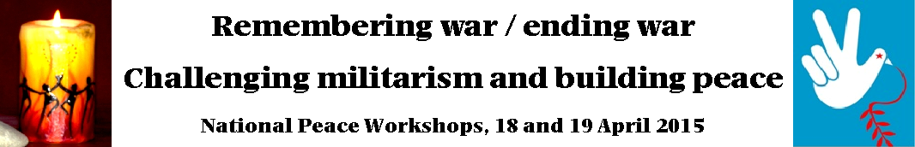
Registration form and programme

Please note: Pre-registration is necessary for catering purposes, and it is essential that you let us know by Tuesday, 14 April, if you are coming along to the peace workshops - you can either fill in this form and email it to pma@xtra.co.nz with ‘NPW 2015 registration’ in the subject line of your message, or leave a message at 04 382 8129 with these details:

Name:

Contact email or phone number:

Participation (please cross out or delete those which do not apply):
- I will be coming along to all the sessions on Saturday and Sunday, or
- I will be coming to the sessions on Saturday, or
- I will be coming to the sessions on Sunday

Food requirements (please cross out or delete those which do not apply):
- omnivorous - vegetarian - vegan

Registration - $10 or $30 (whichever you can afford) - please fill in this section:
Registration $ Donation $ = Total $ .

Payment options (please cross out or delete those which do not apply):
- I have paid by internet banking to account no. 02 0536 0323908 08 - please write your name and ‘NPW’ in the reference sections so we know who it's from and what it's for; or
- I will pay by cheque (payable to ‘Peace Movement Aotearoa’) or cash - please bring your payment with this form to the peace workshops, or
- I am a speaker, presenter or panelist (no payment required)

Receipt: if you would like a receipt, please write your address here:

Venue: The peace workshops will be in the St Andrew’s Conference Centre Hall, 30 The Terrace, Wellington (entrance on the north side of the church), except for the opening session on Saturday morning which will be in the church.

Links to share: On Facebook https://www.facebook.com/events/972037769491199 - Poets for Peace https://www.facebook.com/events/667384243367315 - Web page http://www.converge.org.nz/pma/npw2015.htm
Programme

Saturday, 18 April
- 9.40am to 10.00am - Registration
- 10.00am to 12.30pm - Opening session: Introduction and presentations (includes a tea / coffee break):
- Remembering WW1 in the context of ongoing militarism, Edwina Hughes, Peace Movement Aotearoa
- Challenging militarism and building peace in the Pacific, Dr Pala Molisa, Lecturer, Victoria University
- 12.30pm to 1.30pm - Lunch
- 1.30pm to 3.00pm - Workshops: Speak peace in a world of conflict, learn about compassionate nonviolent communication, a practical and learnable process for communicating with empathy, honesty, confidence and compassion, with Sophia Tara, Director, Compassionate Communication Centre - or - Writing workshop: how to write a peace poem (and the opportunity to read your poem during the Poets for Peace evening event if you wish), with Teresia Teaiwa, poet and writer.
- 3.00pm to 3.30pm - Afternoon tea
- 3.30pm to 5.00pm - Workshops: Men, masculinity and militarism, a discussion with Pala Molisa - or - Ukuleles for peace, if you want to strum and sing some peace songs, then BYO ukulele (or use one of ours, there are 7 spare ukuleles so first come first served) and learn how to play, or just come and sing-along with us, with Sophia Tara, Mighty Ukes for Peace.
- 7.00pm to 9.30pm - Poets for Peace - an evening of poetry featuring * Teresia Teaiwa * Maria MacMillan * Janis Freegard * Sophia Tara * Ali Jacs * Martin de Jong * Meg Hartfield * Vivienne Plumb * Tim Jones * Madeleine Slavik * and more, with a musical interlude by Mighty Ukes for Peace. Entry by donation, all proceeds to a West Papua peace and justice initiative.

Sunday, 19 April
- 1.30pm to 3.00pm - Churches challenging militarism and building peace, a panel with presentations by Stephanie du Fresne, Quaker Peace and Service; Bishop Richard Randerson, Anglican Church in Aotearoa, New Zealand and Polynesia; Rev Jenny Dawson, Christian World Service; Paul Barber, Policy Advisor, NZ Council of Christian Social Services; and Lisa Beech, Advocacy and Research Manager, Caritas; followed by discussion
- 3.00pm to 3.30pm - Afternoon tea
- 3.30pm to 5.00pm - Closing session: Make peace not war, reflections by weekend speakers, panelists and participants

