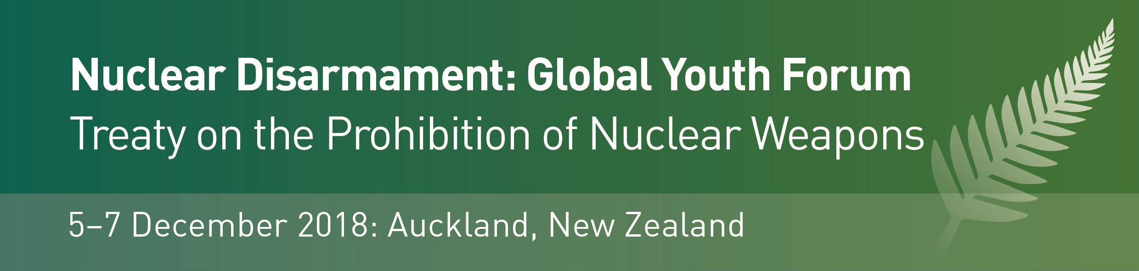

Application to attend for NZ Youth
closing Friday 26 October 2018
Please complete the form below to register your interest to take part in the Global Youth Forum, and send to GYFDecember2018@gmail.com by Friday 26 October. Successful applicants will be advised early November, and supplied with programme information.
- Interest statement: your application should be accompanied by a short outline describing your interest in global disarmament and nuclear non-proliferation issues, below.
- Funding assistance: we have a limited amount of funding assistance available to support participants travelling from outside Auckland. If you would like to apply for a contribution towards your travel costs please see below.
Full Name
Family Name  First / Given Names | Type here…
Date of Birth  DD/MM/YEAR | Type here…
Current Residential Address | Type here…
Nationality  You are also welcome to indicate here your Iwi and/or ethnic affiliation(s) | Type here…
Name of Tertiary Institution OR current occupation | Type here…
Details of relevant study and/or research  Current or recent | Type here…
Key Contact  A University and/or other referee who may be contacted in support of your application | Type here…

Interest statement: please provide below a short outline describing your interest in global disarmament and nuclear non-proliferation issues, current research and/or involvement in this and/or related areas, and the reason why you would like to be selected to attend the Global Youth Forum 2018. Explain why your attending this conference would be meaningful for you (max 200 words).
Type here…

Funding assistance: Conference funding, in the form of a contribution towards travel and accommodation expenses for those travelling from outside Auckland, may be available on a limited basis– please enquire here if you would like to apply for this, outlining your circumstances.
Type here…

* APPLICATIONS CLOSE FRIDAY 26 OCTOBER 2018 *

