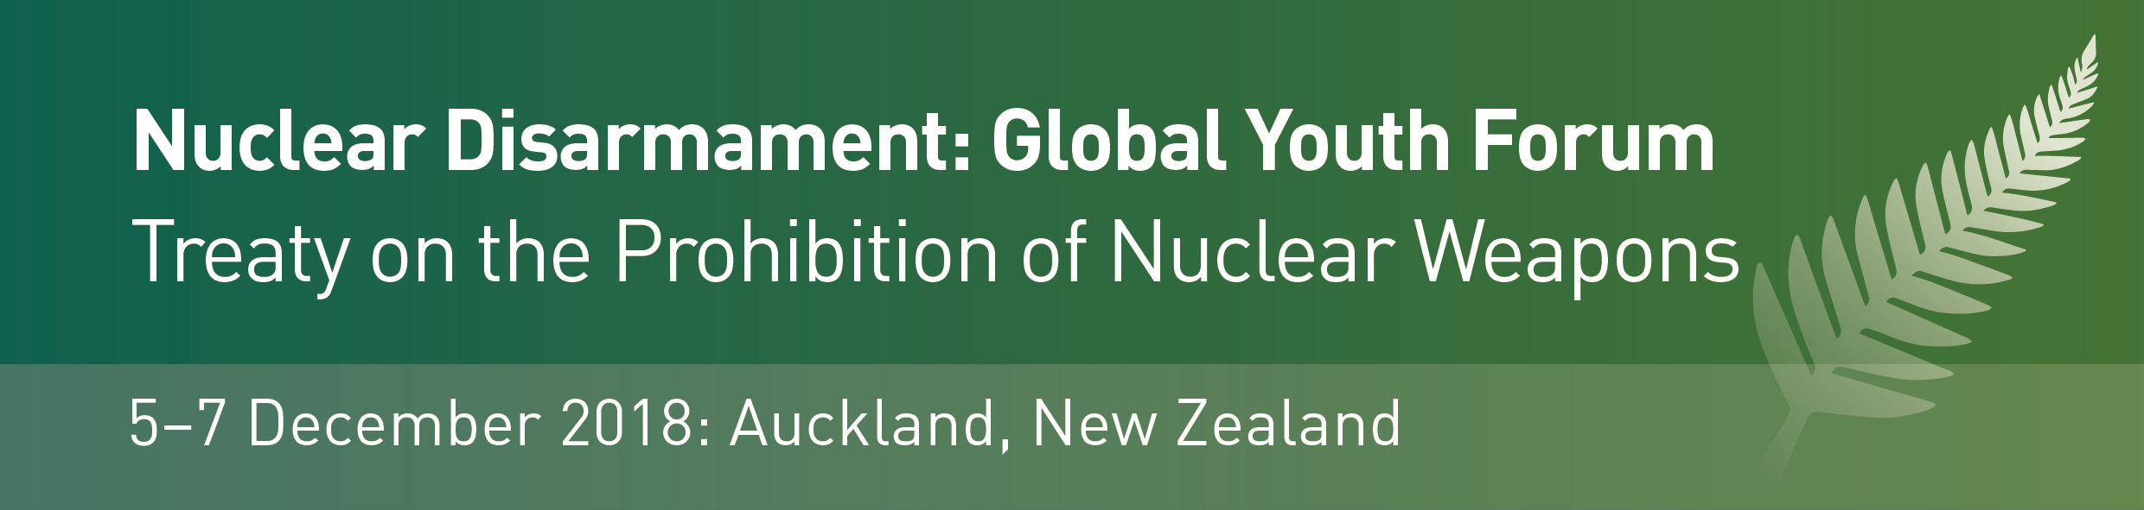

Invitation to New Zealand Youth

The Global Youth Forum on the Treaty on the Prohibition of Nuclear Weapons will be held in Auckland, New Zealand, from 5-7 December 2018. Attended by a range of New Zealand and International Youth, the Forum will feature discussion and latest updates on global disarmament and nuclear non-proliferation issues.
The Global Youth Forum will run concurrently with an intergovernmental conference on the Treaty on the Prohibition of Nuclear Weapons (TPNW) for Pacific Island countries, which will be hosted by the New Zealand Ministry of Foreign Affairs and Trade. Speakers and leading voices engaged in the Pacific Conference will join elements of the Global Youth Forum programme, to update attendees on latest developments in this field. Prominent speakers include Beatrice Fihn, Director of the International Campaign to Abolish Nuclear Weapons (ICAN) which received the 2017 Nobel Peace Prize for its work on the Treaty on the Prohibition of Nuclear Weapons (TPNW). Other prominent speakers include international academics: Dr Zia Mian of Princeton University, and diplomatic representatives from the core group of countries that lead the TPNW process.
Global Youth Forum participants will also attend a reception hosted by New Zealand Deputy Prime Minister and MFA/MDAC, Rt Hon Winston Peters, and a number of other exciting events.
We welcome applications to attend from New Zealand students engaged in an appropriate field of study and/or research, and recent graduates. Maori and Pasifika students are warmly invited to apply.
Please complete the attached application form and email this to :
GYFDecember2018@gmail.com by 26 October.
Applicants will be advised of their success early November.
* Conference funding, in the form of a contribution towards travel and accommodation expenses for those travelling from outside Auckland, may be available – please enquire*

