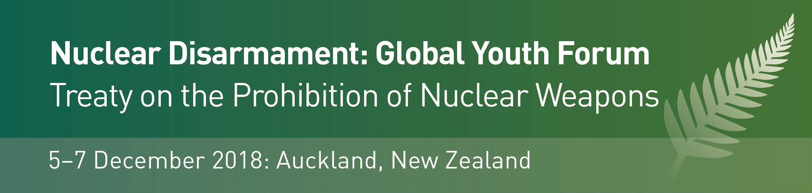

Invitation to Pacific Youth:
Apply to attend the Global Youth Forum 2018

The Global Youth Forum on the Treaty on the Prohibition of Nuclear Weapons will be held in Auckland, New Zealand, from 5-7 December 2018. The Forum will feature discussion and latest updates on global disarmament and nuclear non-proliferation issues.
The Global Youth Forum will run concurrently with an intergovernmental conference on the Treaty on the Prohibition of Nuclear Weapons (TPNW) for Pacific Island countries, which will be hosted by the New Zealand Ministry of Foreign Affairs and Trade. Speakers and leading voices engaged in the Pacific Conference will join elements of the Youth Forum programme, to update attendees on latest developments in this field. Prominent speakers include Beatrice Fihn, Director of the International Campaign to Abolish Nuclear Weapons (ICAN) which received the 2017 Nobel Peace Prize for its work on the TPNW. Other prominent speakers include international academics: Dr Zia Mian of Princeton University, and diplomatic representatives from the core group of countries that lead the TPNW process.
Youth Forum participants will also attend a reception hosted by New Zealand Deputy Prime Minister and MFA/MDAC, Rt Hon Winston Peters, and a number of other exciting events.
Pacific Youth, studying and/or engaged in an appropriate field of research or activity, are warmly invited to apply to attend.

Application to attend
closing Friday 26 October 2018
Please complete the form below to register your interest to take part in the Global Youth Forum, and send to GYFDecember2018@gmail.com by Friday 26 October. Successful applicants will be advised early November, and supplied with programme information.
- Interest statement: your application should be accompanied by a short outline (200 words max) describing your interest in global disarmament and nuclear non-proliferation issues.

Full Name
Family Name  First / Given Names | Type here…
Date of Birth  DD/MM/YEAR | Type here…
Current Residential Address | Type here…
Nationality  You are also welcome to indicate here your Iwi and/or ethnic affiliation(s) | Type here…
Name of Tertiary Institution OR current occupation | Type here…
Details of relevant study and/or research  Current or recent | Type here…
Key Contact  A University and/or other referee who may be contacted in support of your application | Type here…

Interest statement: please provide below a short outline describing your interest in global disarmament and nuclear non-proliferation issues, current research and/or involvement in this and/or related areas, and the reason why you would like to be selected to attend the Global Youth Forum 2018. Explain why your attending this conference would be meaningful for you (max 200 words).
Type here…

