“Neo Colonisation of Pacific Media in New Zealand”

Pacific Islands Media Association Conference
Auckland University of Technology
Conference Centre, WA Building
Wellesley St, Auckland
8 & 9 October 2004

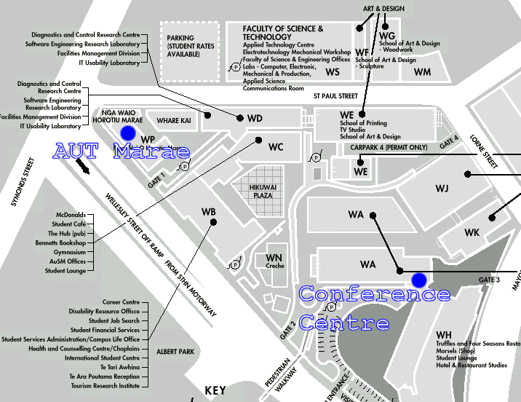

REGISTRATION REPLY FORM

Please fill in the forms attached and send to the address below.

Pacific Islands Media Association, PO Box 6343, Wellesley St, Auckland
Contact: Sandra Kailahi, PIMA Secretary: 021 441 443 or email: skailahi@tvnz.co.nz
Website: http://www.pima.org.nz

REGISTRATION FORM

PERSONAL DETAILS:

Surname: |  | Firstname:
(as required on your name badge)
Title: |  | Organisation:
Address:
Phone: (w) | ( ) |  | Ethnicity:
Phone: (h) | ( ) |  | Fax: |  | ( )
Mob: | ( ) |  | Email:

REGISTRATION FEE

Government Departments: $100.00 per person
Single: $85.00 per person
PIMA Member: $65.00 per person
5 or more from same organisation: $70.00 per person
Individual members: $70.00 per person
Corporate members: $50.00 per person
Students: $40.00 person

PAYMENT ENCLOSED

Payment is by cheque only at this time. For alternative payment arrangements please e-mail: skailahi@tvnz.co.nz

Please make cheques payable to: Pacific Island Media Association.

EXTRA FORMS FOR GROUPS:

Surname: |  | Firstname:
(as required on your name badge)
Title: |  | Organisation:
Phone: (w) | ( ) |  | Ethnicity:
Phone: (h) | ( ) |  | Fax: | ( )
Mob: | ( ) |  | Email:

Surname: |  | Firstname:
(as required on your name badge)
Title: |  | Organisation:
Phone: (w) | ( ) |  | Ethnicity:
Phone: (h) | ( ) |  | Fax: | ( )
Mob: | ( ) |  | Email:

Surname: |  | Firstname:
(as required on your name badge)

Title: |  | Organisation:
Phone: (w) | ( ) |  | Ethnicity:
Phone: (h) | ( ) |  | Fax: | ( )
Mob: | ( ) |  | Email:

